**DisasterShield**

**Your disaster recovery and backup partner**

**Student name: Diya Vijay**

**Student ID: 35389338**

**IP address: 209.38.122.155**

Contents

PART 1 - SETTING UP THE WEB SERVER 3

PART 2 – INSTALL APACHE, PHP AND MYSQL 3

PART 3 – INSTALL AND SET UP WORDPRESS 4

PART 4 – CONNECT DOMAIN FROM GODADDY AND DIGITALOCEAN 7

PART 5 – SET UP SSL (HTTPS) 7

PART 6 – SETTING UP THE BACKUP SCRIPT 8

PART 7 – CREATE THE STATUS PAGE 10

PART 8 – DESIGN THE WEBSITE WITH WORDPRESS 10

PART 9 – AUTOMATE BACKUPS WITH CRON 12

# PART 1 - SETTING UP THE WEB SERVER

1. Create a droplet on DigitalOcean

* Create a droplet with:
* Ubuntu 22.04 (or latest)
* 1 vCPU, 1GB RAM
* Data center: Bangalore or nearest
* Save the droplet IP address, in this case 209.38.122.155

1. Log into your Linux terminal, and connect to your droplet via SSH

* Enter the password you gave your droplet

# PART 2 – INSTALL APACHE, PHP AND MYSQL

1. Update your system

sudo apt update && sudo apt upgrade -y

1. Install Apache

sudo apt install apache2 -y

1. Install PHP and required modules

sudo apt install php libapache2-mod-php php-mysql -y

1. Install MySQL

sudo apt install mysql-server -y

# PART 3 – INSTALL AND SET UP WORDPRESS

1. On your Linux terminal, write this down to download and extract WordPress

cd ~

wget https://wordpress.org/latest.tar.gz

tar -xvzf latest.tar.gz

sudo rsync -av wordpress/ /var/www/html/

1. Set the correct permissions

sudo chown -R www-data:www-data /var/www/html/

sudo chmod -R 755 /var/www/html/

1. Configure MySQL database

sudo mysql -u root -p

1. After configuring the database, run:

CREATE DATABASE wordpress;

CREATE USER 'wpuser'@'localhost' IDENTIFIED BY 'yourpassword';

GRANT ALL PRIVILEGES ON wordpress.* TO 'wpuser'@'localhost';

FLUSH PRIVILEGES;

EXIT;

1. Open your browser and go to ‘http://209.38.122.155, where you should see a WordPress setup screen

* First choose your language, and then proceed.

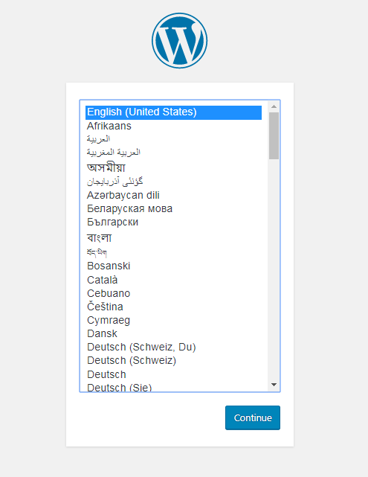

* Enter your details

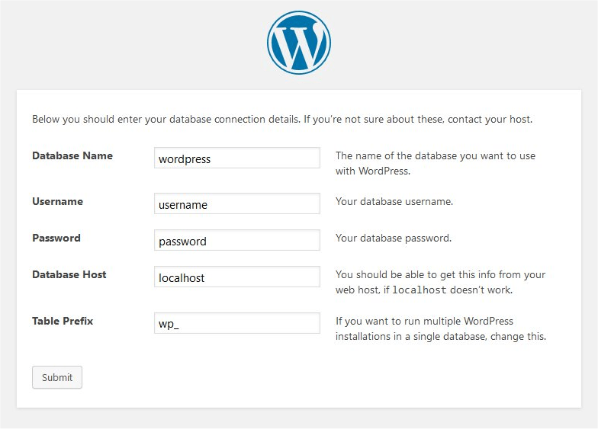

* After you enter your details, finally click submit.

1. Click the “Run the installation” button
2. You will reach a page where they request you for your site information

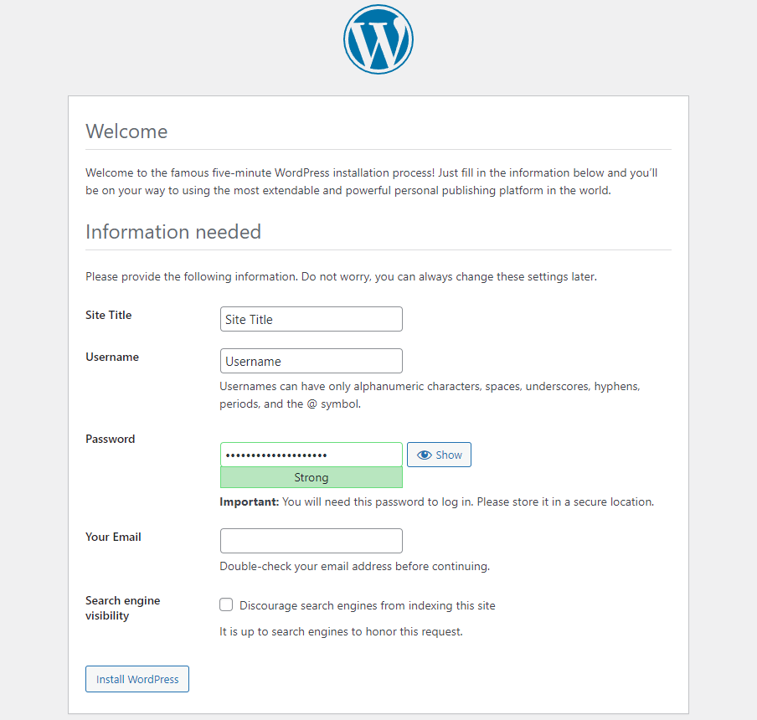

Add the following information:

* Site Title: DisasterShield
* Username: admin (or anything you prefer)
* Password: choose a strong password
* Email Address: your email
* Search Engine Visibility: leave unchecked

When you are done, click “Install Wordpress”

1. A screenshot of a login box

   AI-generated content may be incorrect.Login to WordPress

# PART 4 – CONNECT DOMAIN FROM GODADDY AND DIGITALOCEAN

1. Go to the GoDaddy DNS settings
2. Change the GoDaddy nameservers to this:

1. On DigitalOcean, go to the DNS settings and add this:

Notice you will also find these from the GoDaddy settings:

# PART 5 – SET UP SSL (HTTPS)

1. On your Linux terminal, Install Certbot

sudo apt install certbot python3-certbot-apache -y

1. Run Certbot

sudo certbot --apache

1. Follow the prompts given and choose your domain (disastershield.xyz)

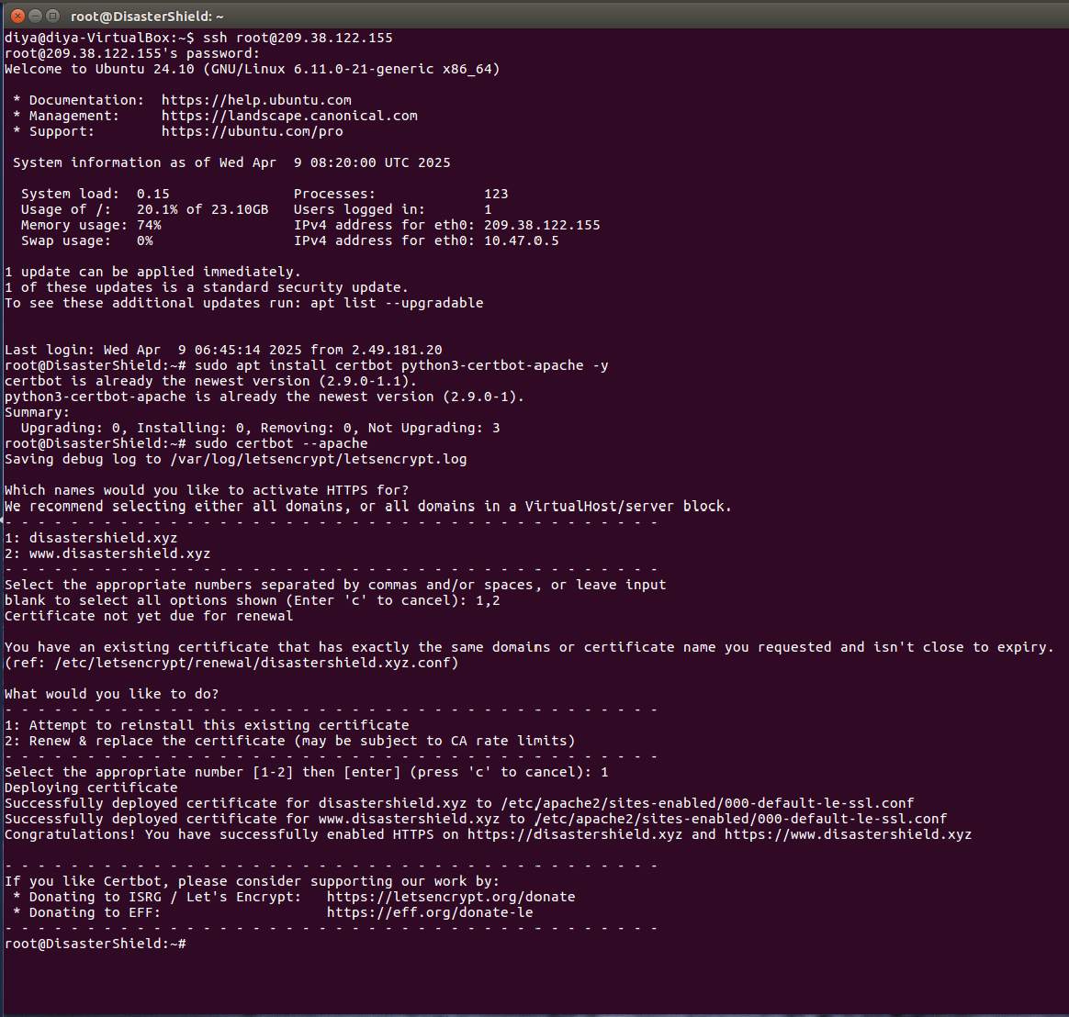

# PART 6 – SETTING UP THE BACKUP SCRIPT

1. On your Linux terminal, add this prompt to open a shell file to create the script.

sudo nano /usr/local/bin/disastershield-backup.sh

1. From the backup.sh file in the repository, paste this program:

#!/bin/bash

BACKUP_DIR="/var/backups/disastershield"

TIMESTAMP=$(date +"%Y-%m-%d %H:%M:%S")

FILENAME_TIMESTAMP=$(date +"%Y-%m-%d_%H-%M-%S")

BACKUP_FILE="$BACKUP_DIR/backup_$FILENAME_TIMESTAMP.tar.gz"

mkdir -p "$BACKUP_DIR"

tar -czf "$BACKUP_FILE" /var/www/html/wp-content

echo "Last backup created: $TIMESTAMP" > /var/www/html/last_backup.txt

Then click CTRL+O and Enter to save, and CTRL+X to exit from that screen.

1. Once you’re back to the terminal, add this to make the file executable

sudo chmod +x /usr/local/bin/disastershield-backup.sh

1. Run this to test

sudo /usr/local/bin/disastershield-backup.sh

1. Run this to view the backups

ls /var/backups/disastershield

Your output should look like this:

# PART 7 – CREATE THE STATUS PAGE

1. Create the PHP file

sudo nano /var/www/html/status.php

1. From the ‘statusphp.txt’ file of the repository, copy the program
2. Click CTRL+O and Enter to save, proceeded by CTRL+X to exit
3. Run the link in the browser. Your status page in the browser should look like this:

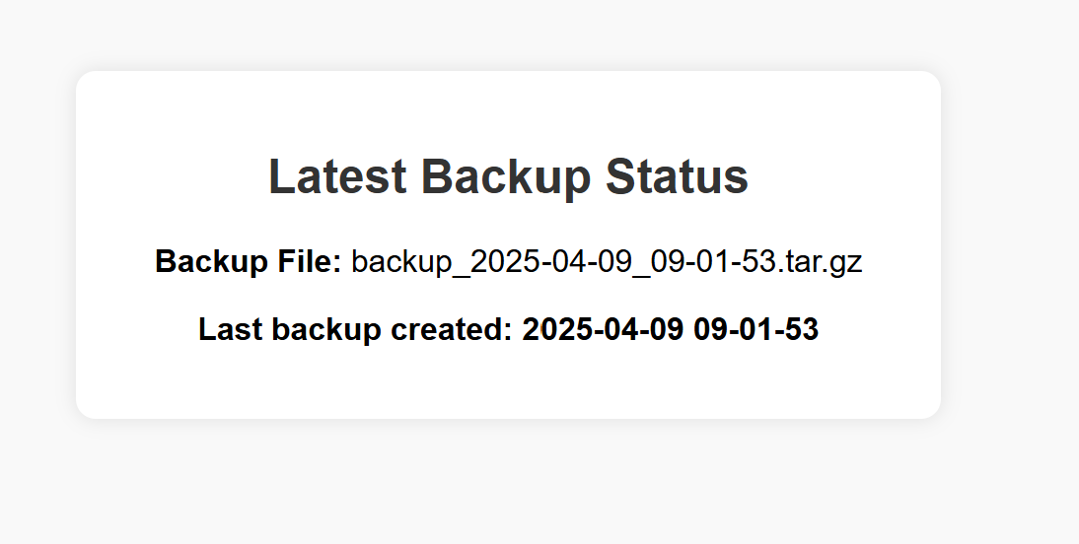

1. Do the same with ‘triggerbackupphp.txt’.

# PART 8 – DESIGN THE WEBSITE WITH WORDPRESS

1. Log in to WordPress

https://disastershield.xyz/wp-admin

1. Install the ASTRA theme and Elementor to edit

* For the theme, go to Appearance 🡪 themes 🡪 Add new 🡪 Search for “Astra”
* Click install and activate
* For Elementor, go to Plugins 🡪 Install “Elementor Website Builder”

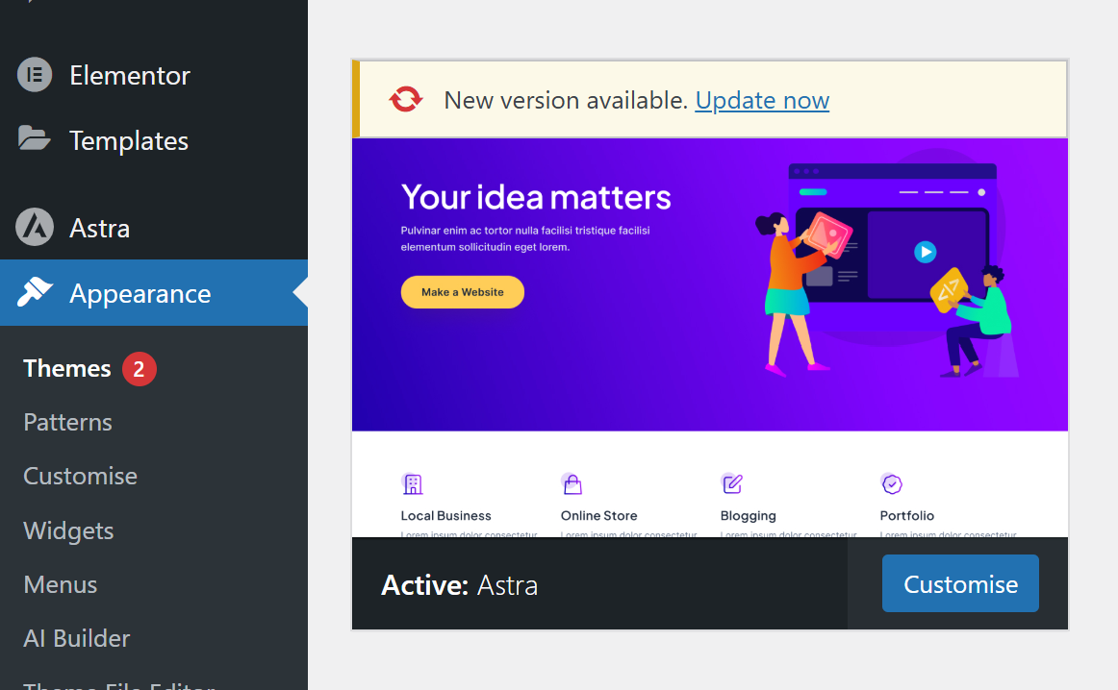



1. A screenshot of a computer

   AI-generated content may be incorrect.To start editing your website, go to “Pages” and click on “Add new page”
2. When creating each page, hover over the Title, click on “Edit” and then click on “Edit with Elementor”

1. Create the pages for “Home”, “About”, “Status” and “Contact us”
2. When creating the buttons on the Status page, include the links for:

* <https://disastershield.xyz/trigger_backup.php>
* <https://disastershield.xyz/status.php>

# PART 9 – AUTOMATE BACKUPS WITH CRON

1. On your Linux terminal, add this:

sudo crontab -e

1. Add this line to automate your backups at 2 am everyday:

0 2 * * * /usr/local/bin/disastershield-backup.sh

Now you are complete! You have your fully functional DisasterShield website up and running again, ready to handle your backups!